Q1. Find out the total profit, sales, discount and shipping cost according

to segment.

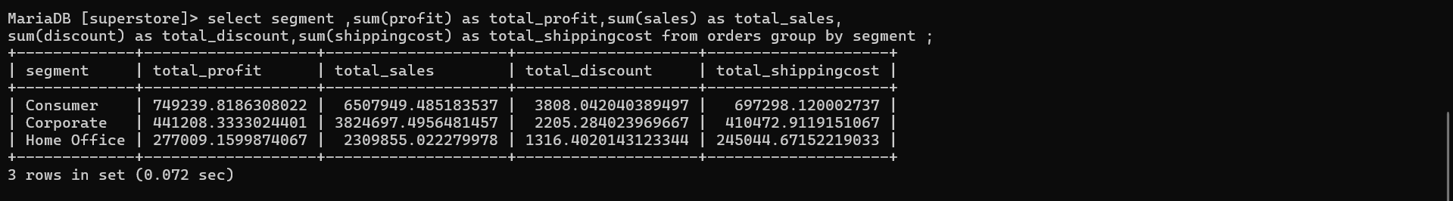

Q2. Top 10 corporate customer who gave best sale.

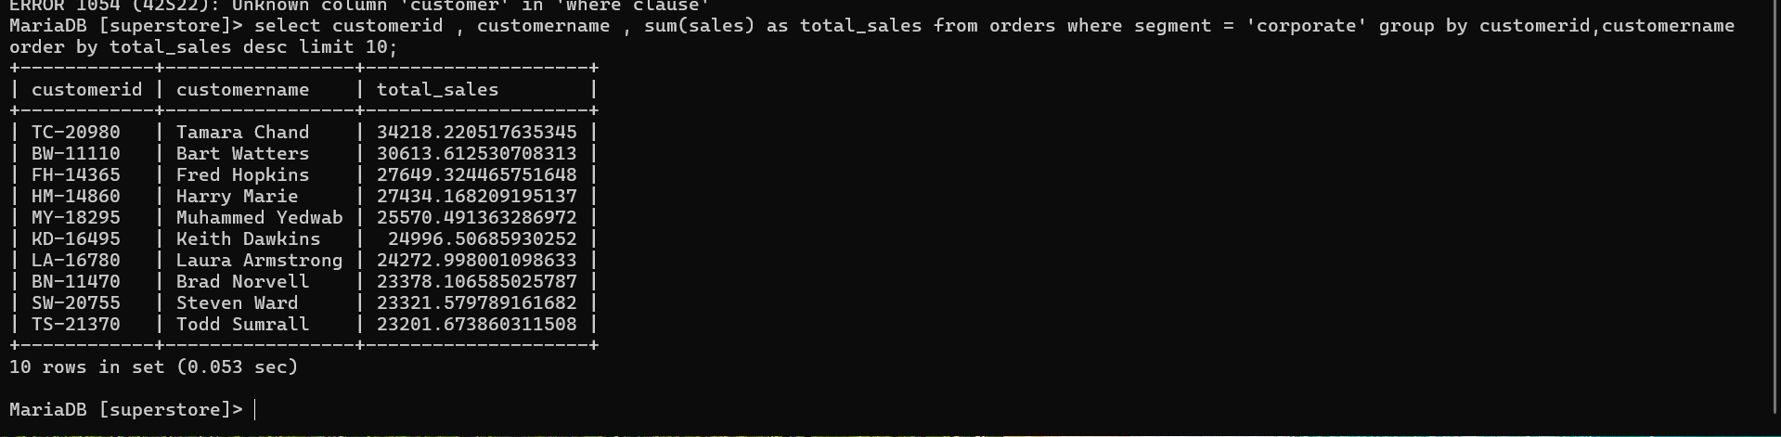

Q3. How many order received in India on each segment?

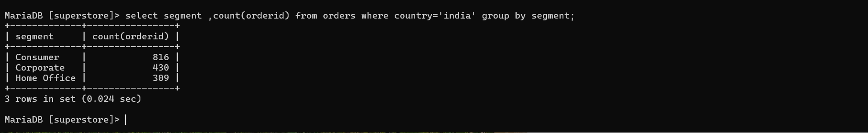

Q4. What would be the % of profit with respect to sales for santiago state by each order priority.

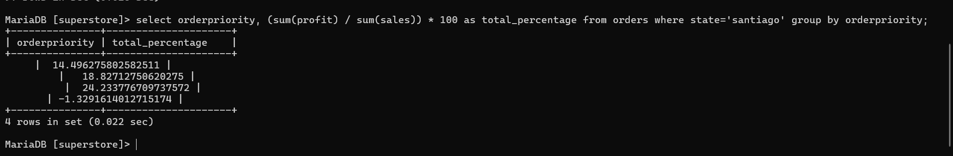

Q5. What is the avg shipping cost of 1st class for top 15 customers in south-east asia for home office site?

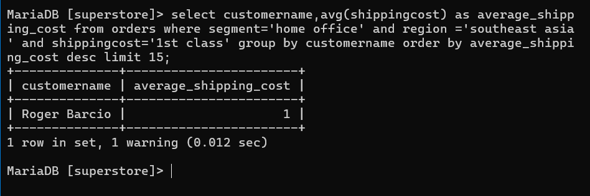

Q6. What are the total no of orders for each catagory by each segment order date wise?

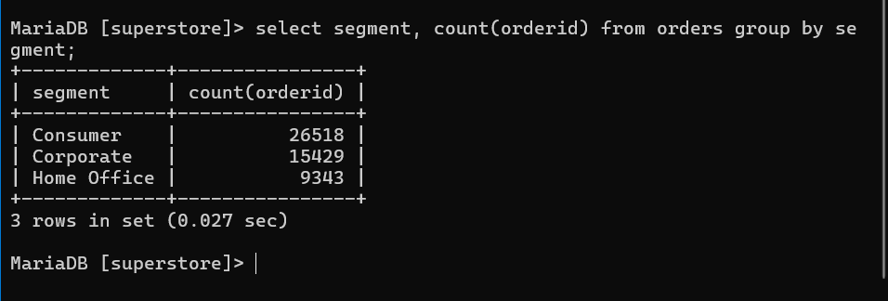

Q7. How many product shipped by first class in each priority.

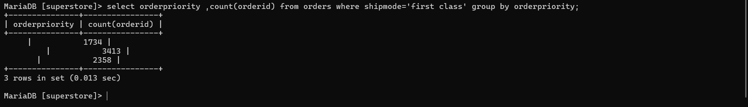

Q8. Find out total sales and profit for each category with low order priority and zero discount.

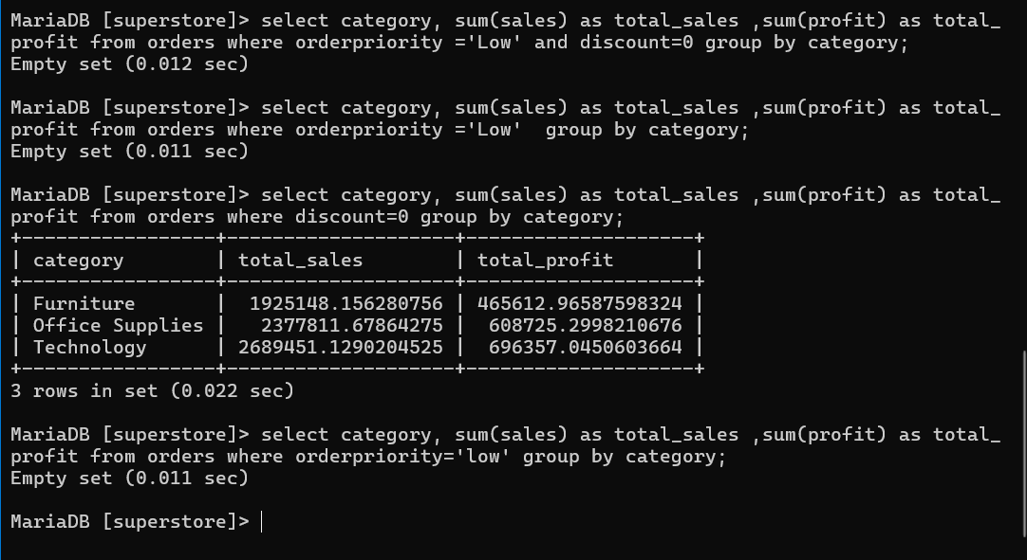

Q9. Name the cities of Australia with % of sales?

Q10. What is the total sales and quantity for top 5 samsung products in APAC Market for the year 2014?

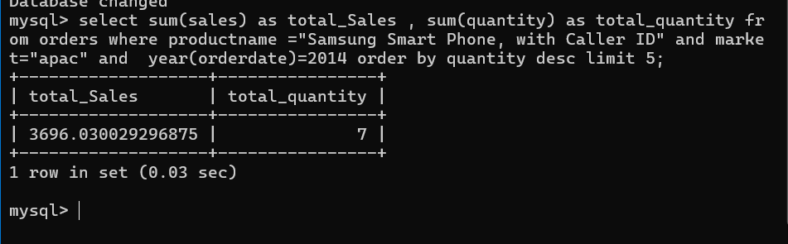

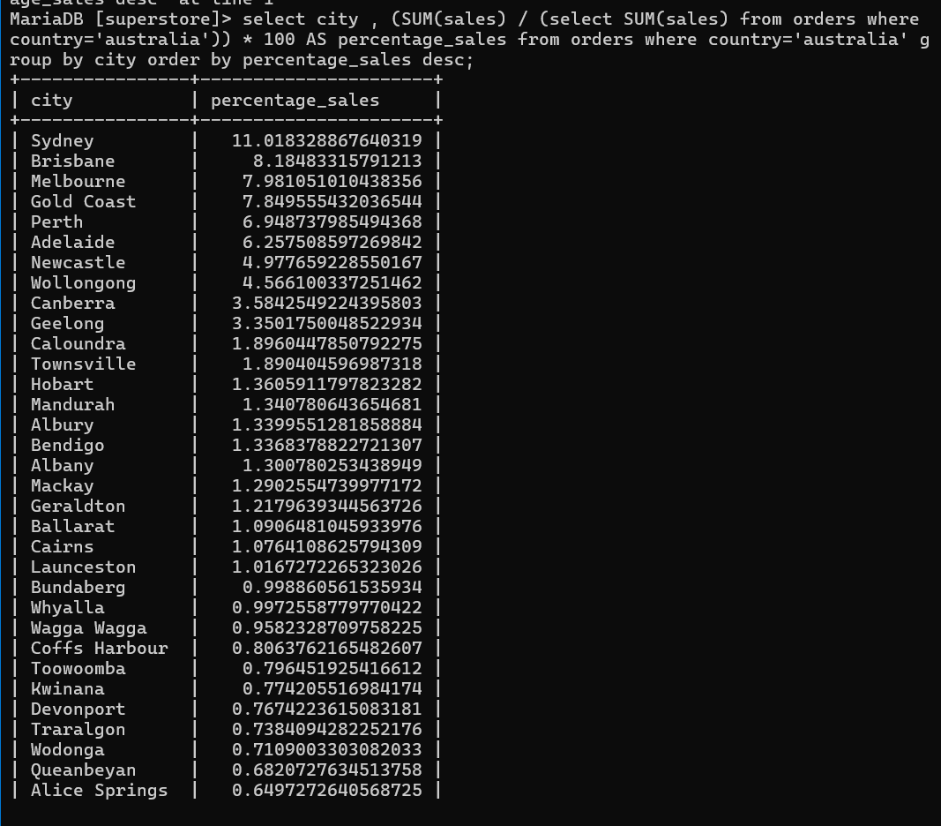

Q10. What is the total sales and quantity for top 5 samsung products in APAC Market for the year 2014?

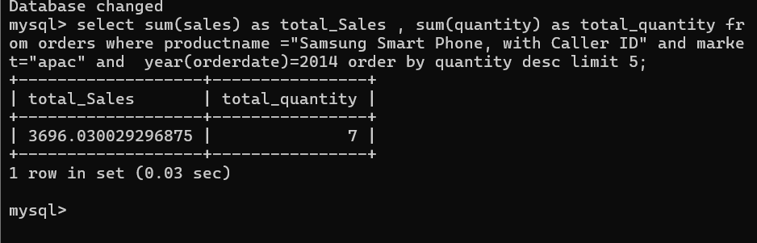

Q11. What % of shipping cost contribute in sales for Nokia Products in NEW ZEALAND country ?